PREDICTION OF MOBILE PHONE PRICE RANGE
USING CLASSIFICATION MODELS

A MINI PROJECT REPORT
Submitted in partial fulfilment of the requirements
for the award of the degree of
BACHELOR OF TECHNOLOGY
in
COMPUTER SCIENCE AND ENGINEERING

Submitted by
Anshu Kumari
Roll No: 23GE1A05__
Keshav Durgesh
Roll No: 23GE1A0529
Krishna Murari
Roll No: 23GE1A0530
Pranjal Kumar Mishra
Roll No: 23GE1A0549

Under the Guidance of
__________________________
Assistant Professor
Department of Computer Science and Engineering

( College Logo Here)

DEPARTMENT OF COMPUTER SCIENCE AND ENGINEERING
BHASKAR ENGINEERING COLLEGE
Affiliated to JNTUH
[HYDERABAD, TELANGANA]
Academic Year: 2025–2026

MINI PROJECT REPORT
📱 Prediction of Mobile Phone Price Range Using Classification Models

ACKNOWLEDGEMENT
I would like to express my sincere gratitude to my project guide and faculty members for their valuable guidance and support throughout the completion of this project. I also thank my institution for providing the necessary resources and facilities. Finally, I acknowledge the use of publicly available datasets and documentation that contributed to the successful completion of this project.
1. ABSTRACT
This project presents the development of a machine learning-based system for predicting the price range of mobile phones using classification techniques. A dataset containing various mobile specifications such as battery power, RAM, internal memory, camera resolution, and connectivity features was used to train and evaluate multiple classification algorithms including Logistic Regression, K-Nearest Neighbours, Decision Tree, and Random Forest.
Among the evaluated models, Random Forest achieved the highest accuracy of 89.25% and was selected as the final model. The trained model was saved using Pickle and deployed as a web application using Streamlit, enabling real-time user interaction.
The project demonstrates an end-to-end machine learning pipeline including data preprocessing, model training, evaluation using confusion matrix, feature importance analysis, and web deployment.

2. INTRODUCTION
The smartphone market has expanded rapidly over the past decade, offering consumers a wide range of devices across multiple price segments. Consumers often find it difficult to assess whether a mobile phone is reasonably priced based on its technical specifications.
Machine Learning (ML) provides intelligent systems capable of learning patterns from data and making predictions. In classification problems, the goal is to categorize input data into predefined classes.
In this project, we develop a classification model that predicts the price range category of a mobile phone based on its hardware and connectivity specifications.
The price categories are defined as:
- 0 – Low Cost
- 1 – Medium Cost
- 2 – High Cost
- 3 – Very High Cost
The system was implemented using Python and deployed using Streamlit for real-time user interaction.

3. PROBLEM STATEMENT
To develop a machine learning model that accurately predicts the price range category of a mobile phone using its technical specifications.

4. OBJECTIVES
The main objectives of this project are:
- To analyse and understand the mobile price classification dataset.
- To preprocess and scale the dataset appropriately.
- To train multiple classification models.
- To compare model performances.
- To select the best performing model.
- To deploy the trained model as a web application.
- To visualize feature importance for interpretability.

5. LITERATURE REVIEW
Machine learning has been widely used in price prediction and product categorization systems. Classification algorithms such as Decision Trees, Support Vector Machines, and Random Forest have shown strong performance in structured datasets.
Random Forest, an ensemble learning technique, improves predictive accuracy by combining multiple decision trees. It reduces overfitting and handles high-dimensional data efficiently.
Studies have shown that hardware features such as RAM and processor speed are significant indicators of mobile price range.
This project builds upon these machine learning principles to implement a practical prediction system.

6. DATASET DESCRIPTION
The dataset was obtained from Kaggle’s Mobile Price Classification dataset.
It contains 2000 records with 21 columns.
Input Features (20 features):
- battery_power
- blue (Bluetooth)
- clock_speed
- dual_sim
- fc (Front Camera)
- four_g
- int_memory
- m_dep (Mobile Depth)
- mobile_wt
- n_cores
- pc (Primary Camera)
- px_height
- px_width
- ram
- sc_h
- sc_w
- talk_time
- three_g
- touch_screen
- wifi
Target Variable:
- price_range (0–3)

7. METHODOLOGY
The project was implemented in the following stages:

7.1 Data Loading
The dataset was loaded using Pandas:
data = pd.read_csv("train.csv")

7.2 Data Preprocessing
- Features and target were separated.
- No missing values were found.
- Feature scaling was applied using StandardScaler.

7.3 Train-Test Split
The dataset was split into:
- 80% Training data
- 20% Testing data
train_test_split(test_size=0.2, random_state=42)
This ensures model performance is tested on unseen data.

7.4 Feature Scaling
StandardScaler was applied to normalize features.
Reason:
Different features have different ranges (RAM in thousands, Bluetooth 0 or 1).
Scaling ensures fair contribution of all features.

7.5 Model Training
The following classification algorithms were tested:
- Logistic Regression
- K-Nearest Neighbors
- Decision Tree
- Random Forest
Random Forest achieved highest accuracy and was selected.

7.6 Model Evaluation
Accuracy and confusion matrix were used for evaluation.
Accuracy formula:
Accuracy = (Correct Predictions / Total Predictions)

7.7 Model Saving
The trained model and scaler were saved using Pickle:
pickle.dump(model, open("model.pkl", "wb"))
pickle.dump(scaler, open("scaler.pkl", "wb"))

7.8 Deployment
The saved model was integrated into a Streamlit web application.

8. ALGORITHMS USED

8.1 Logistic Regression
A linear classification algorithm that models’ probability using logistic function.

8.2 K-Nearest Neighbours
Classifies data based on similarity with nearest neighbours.

8.3 Decision Tree
Splits data into branches based on feature conditions.

8.4 Random Forest (Selected Model)
Random Forest is an ensemble learning method that builds multiple decision trees and combines their outputs.
Advantages:
- High accuracy
- Reduces overfitting
- Handles large datasets
- Provides feature importance

9. SYSTEM ARCHITECTURE
User Input (Web App)
↓
Data Scaling
↓
Random Forest Model
↓
Prediction Output
↓
Result Display

10. IMPLEMENTATION
Programming Language: Python
Libraries Used:
- Pandas
- NumPy
- Scikit-learn
- Matplotlib
- Streamlit
- Pickle

11. FEATURE IMPORTANCE ANALYSIS
Random Forest provides feature importance scores.
Results showed that:
- RAM had highest influence
- Battery power and pixel resolution also contributed significantly
Feature importance helps interpret model decisions.

12. CONFUSION MATRIX ANALYSIS
The Confusion Matrix is a detailed performance evaluation tool used for classification models. While accuracy provides the overall percentage of correct predictions, the confusion matrix gives class-wise performance information.
In this project, the confusion matrix is a 4×4 matrix corresponding to the four price categories (Low, Medium, High, Very High).
- The rows represent the actual classes.
- The columns represent the predicted classes.
- The diagonal values represent correct predictions.
- Off-diagonal values represent misclassifications.
Most values are concentrated along the diagonal, indicating that the model correctly classifies the majority of instances. Minor misclassifications were observed mainly between adjacent categories such as Medium and High, which is expected due to overlapping specifications.
The confusion matrix confirms that the Random Forest model performs consistently across all classes.
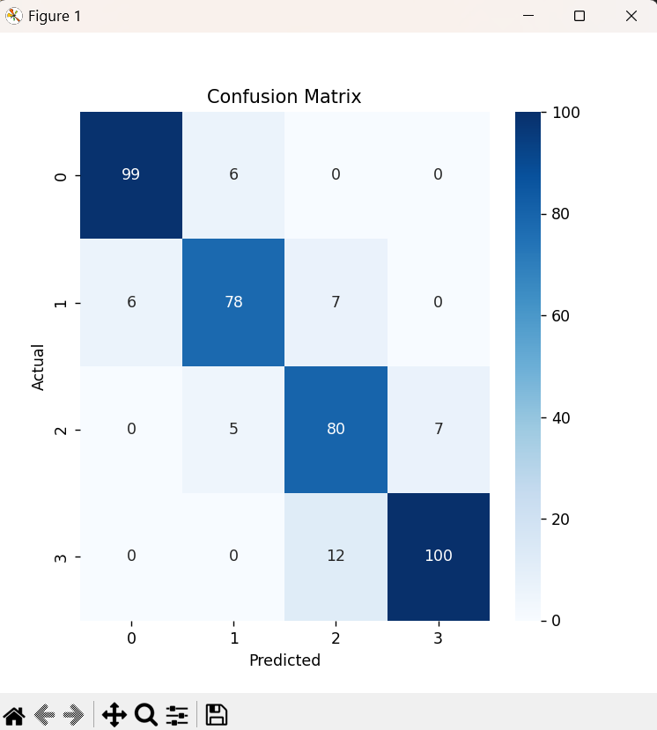
Figure: Confusion Matrix Visualization
13. WEB APPLICATION DEVELOPMENT
The model was integrated into a Streamlit web interface.
Features of Web App:
- User-friendly UI
- Sliders and dropdown inputs
- Real-time prediction
- Feature importance visualization
- Device summary display
The application allows non-technical users to interact with the model.

14. RESULTS
The Random Forest classifier achieved an accuracy of 89.25% on the testing dataset. This indicates that the model correctly predicted the price range for approximately 9 out of 10 mobile phones.
Feature importance analysis revealed that RAM is the most influential feature in determining mobile price range. Other important features include battery power, pixel resolution, and internal memory.
The deployed web application successfully predicts mobile price categories in real-time based on user input.

- Random Forest achieved approximately 89.25% accuracy.
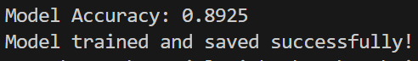
- RAM was identified as the most influential feature.
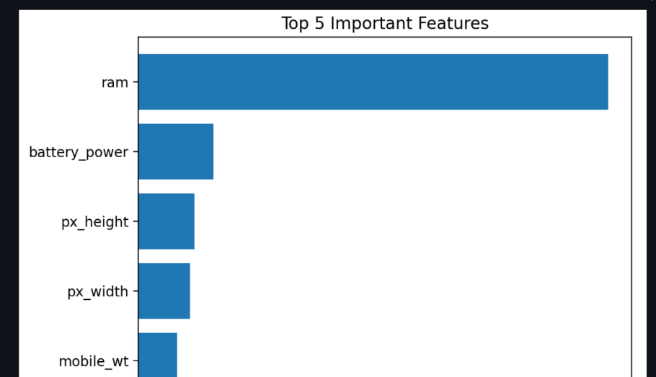
- The deployed application successfully predicted price ranges in real-time.
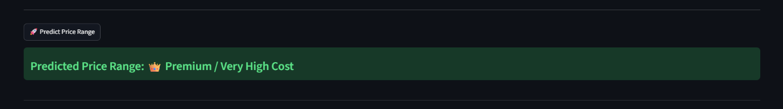

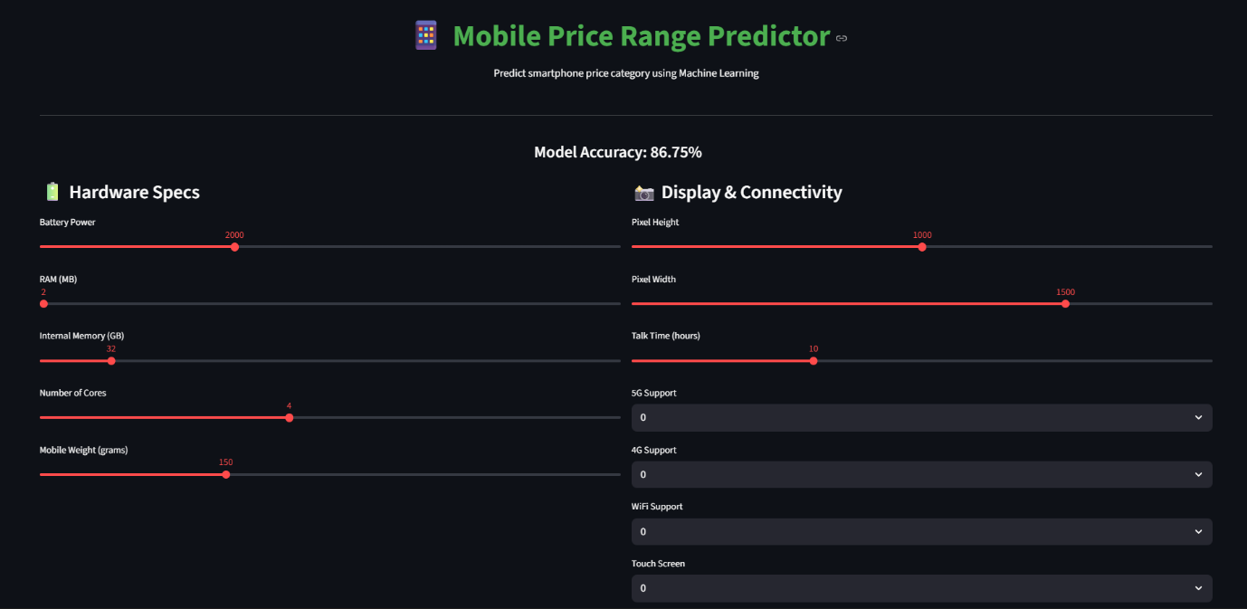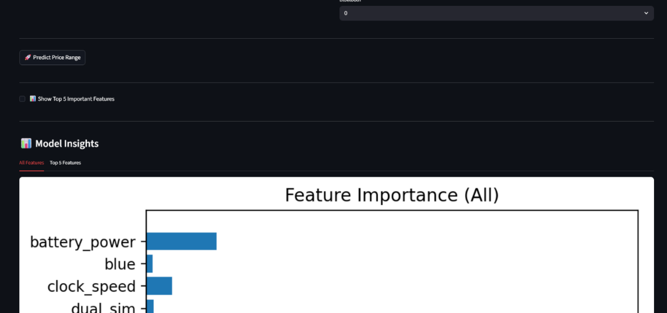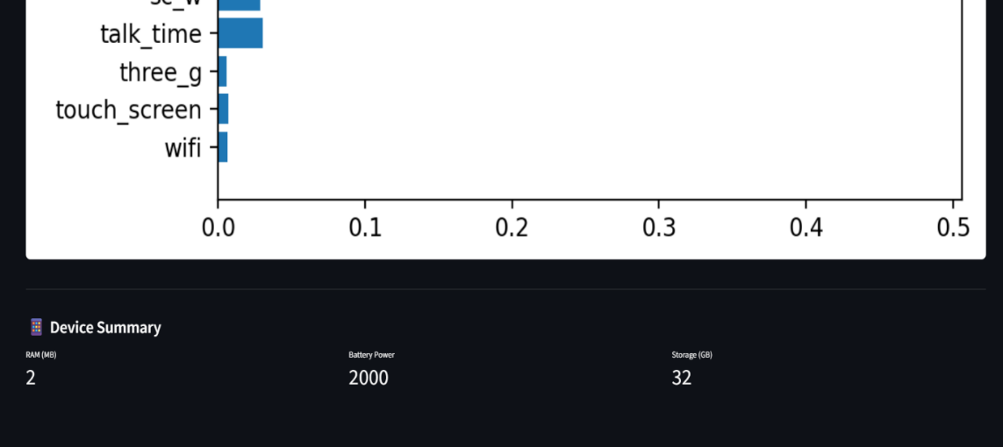

15. ADVANTAGES
- Accurate prediction
- Easy-to-use interface
- End-to-end ML implementation
- Scalable system

16. LIMITATIONS
- Dataset is simulated
- Does not include real-time market pricing
- 5G not originally included in dataset

17. FUTURE SCOPE
- Use real-world market dataset
- Predict exact price using regression
- Integrate cloud database
- Add deep learning models
- Deploy on cloud server permanently

18. CONCLUSION
This project successfully implemented a machine learning classification model to predict mobile phone price ranges based on hardware specifications.
Among multiple algorithms tested, Random Forest achieved the best performance due to its ensemble nature and robustness.
The system was deployed using Streamlit, providing a complete end-to-end machine learning solution.
The project demonstrates practical understanding of supervised learning, classification techniques, model evaluation, and deployment.

19. REFERENCES
- Kaggle – Mobile Price Classification Dataset
- Scikit-learn Documentation
- Streamlit Official Documentation
- Machine Learning Concepts – Standard Textbooks

20. APPENDIX
Include:
- Screenshots of Web Application
- Confusion Matrix Screenshot
- Feature Importance Graph
- Model Accuracy Output

